**13/09/2021 ML LAB 2 2019103573**

**ILLUSTRATION OF 3 ALGORITHMS USING WEKA TOOL**

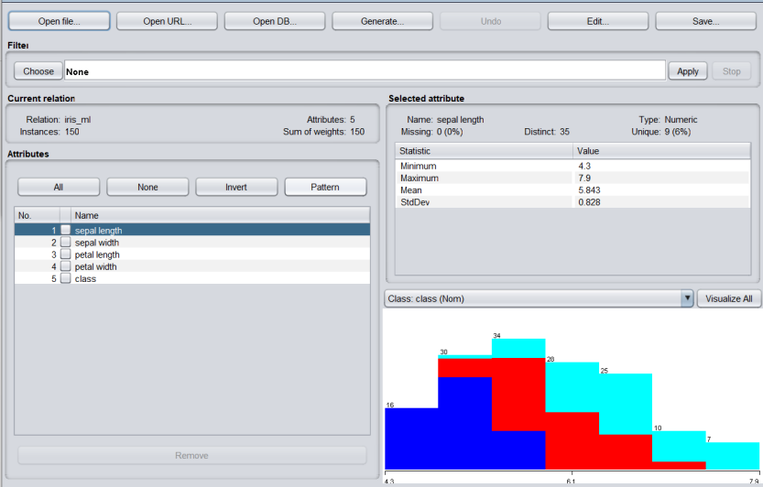**DATASET: IRIS DATASET**

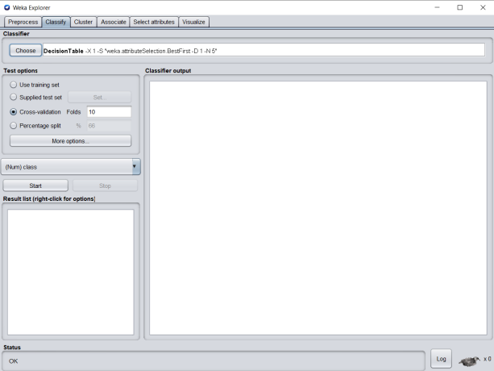**CLASSIFICATION (DECISION TABLE)**

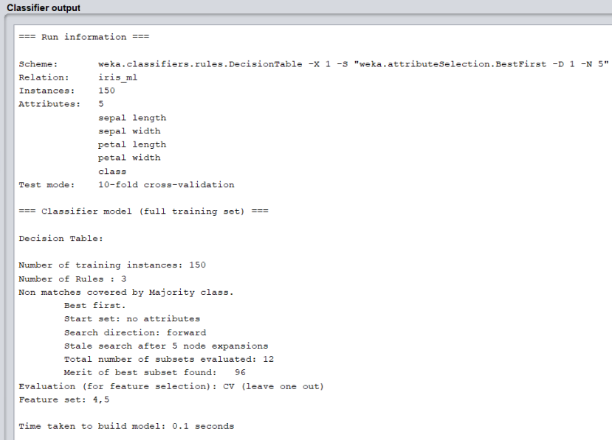

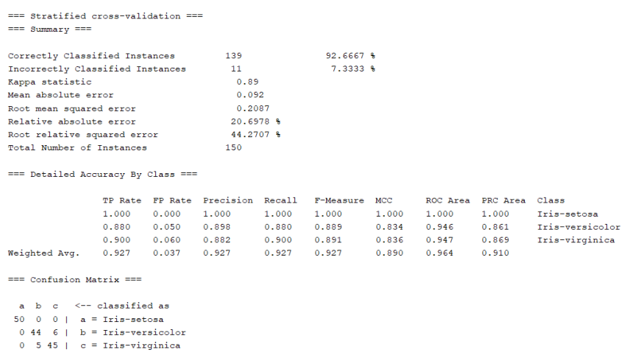**The Accuracy, Confusion Matrix and the terms below can be used as performance metrics**

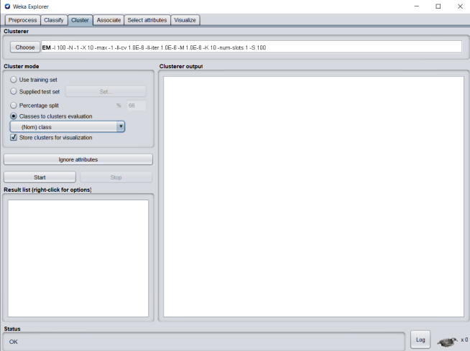**CLUSTERING (EM)**

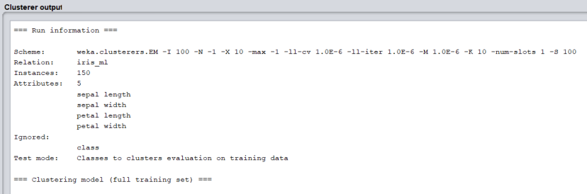

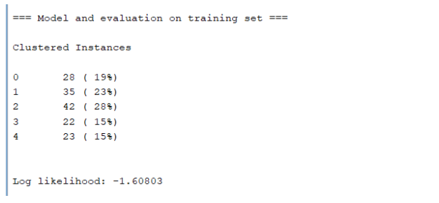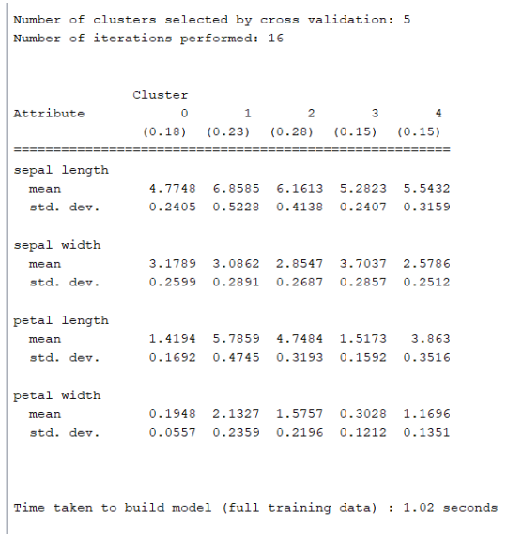

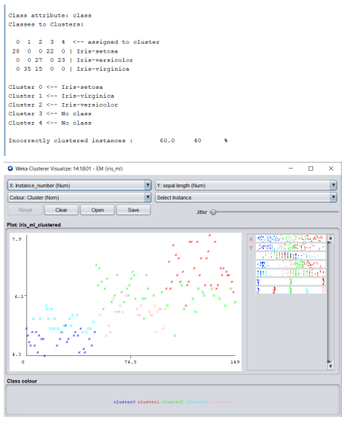**Log likelihood can be used as a performance metric**

**REG 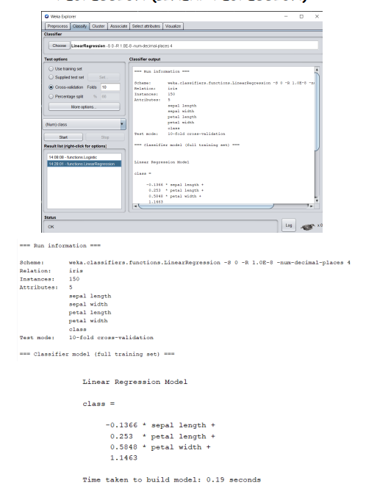RESSION IN LINEAR**

**Root mean squared error and the other terms below can be used as performance metrics**